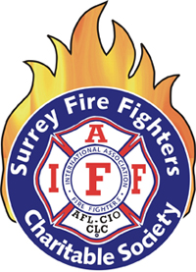
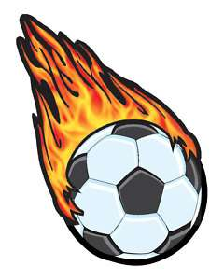
Surrey Fire Fighters’ Charitable Society
Inaugural Soccer Tournament

Group A Group B
VFD ‘B’ - Vancouver Fire Delta
SFD ‘B’ - Surrey Fire SFD ‘A’ - Surrey Fire
Poco FD BFD - Burnaby Fire
City of Surrey VFD ‘A’- Vancouver Fire
RCMP
Round Robin 15 min halves Round Robin 20 min halves
Top 4 teams from each group advance to single knock out playoff
Playoffs 20 min halves
Field 1 | Field 2 | Field 3 | Field 4
9:00 – 9:30  VFD B vs SFD B | 9:00-9:30  RCMP vs Poco FD | 9:00-9:45  DFD vs SFD A | 9:00-9:45  BFD vs VFD A
9:50-10:25  City of Surrey vs VFD B | 9:50-10:25  SFD B vs RCMP | 10:15-11:00  DFD vs VFD A | 10:15-11:00  SFD A vs BFD
10:40-11:15  Poco FD vs City of Surrey | 10:40-11:15  VFD B vs RCMP
11:30-12:05  SFD B vs Poco FD | 11:30-12:05  City of Surrey vs RCMP | 12:00-12:45  DFD vs BFD | 12:00-12:45  SFD A vs VFD A
12:20 – 1:05  VFD B vs Poco FD | 12:20-1:05  SFD B vs City of Surrey
2:00 – 2:45 ¼ Final 1  1st place Group A vs  4th place Group B | 2:00-2:45 ¼ Final 2  2nd place Group A vs  3rd place Group B | 2:00-2:45 ¼ Final 3  3rd place Group A vs  2nd place Group B | 2:00-2:45 ¼ Final 4  4th place Group A vs  1st place Group B
3:30-4:15  Winner ¼ Final 1 vs  Winner ¼ Final 4 | 3:30-4:15  Winner ¼ Final 2 vs  Winner ¼ Final 3
4:45 -5:30
Final

